VP3300
Pairing the VP3300
Using the VP3300
Understanding the LED Indicators
Device Pairing Issues
Identifying a Device
Waking up and reconnecting the Device

The ID TECH VP3300 is a portable payment reader that lets you take payments through magnetic stripe (MSR), chip (EMV), and contactless (NFC) cards using a mobile app.

Pairing the VP3300
Before using the VP3300 for the first time, make sure the battery is fully charged. It takes about 4 to 6 hours to fully charge. A flashing red LED on the back means it’s charging. When it stops flashing, it’s fully charged.
To begin using the VP3300 to accept payments, you must pair the VP3300 with your mobile device using the payment application installed on the device.
Don’t pair the VP3300 from your phone’s Bluetooth settings. Always pair it through the payment app on your device.
It’s best to plug in the device when pairing it for the first time.
To pair the VP3300 with your device, do the following:
- Ensure that Bluetooth is enabled on your phone or tablet, and that no other devices are currently connected.
- Press the power button on the side of the VP3300 to enable Bluetooth pairing.
If the device is connected to a power source, it automatically enables Bluetooth pairing.
- On your mobile device, in the payment application, select the device (for example, “IDTECH-VP3300-#####” where ##### is the last five digits of the serial number located on a label on the bottom of the device).
- The Bluetooth status LED (the top LED on the rear of the device) flashes quickly to indicate that the device is paired and connected.
Using the VP3300

The VP3300 uses Bluetooth to connect to your payment app. When the app starts a payment, you or the customer can swipe, tap, or insert the card.
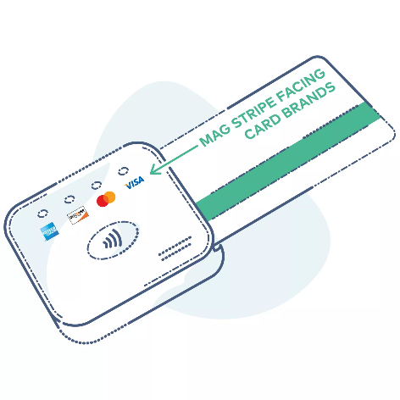

When swiping or inserting a card, make sure the front of the card faces away from you.

Troubleshooting

The following topics provide information for troubleshooting your VP3300 device.
Understanding the LED Indicators
There are three LEDs on the back of the device that show different statuses.
- The top LED indicates the Bluetooth status.
  - If it’s off, Bluetooth is asleep.
  - If it flashes slowly, Bluetooth is on standby.
  - If it flashes quickly, Bluetooth is connected.
- The middle LED lights up when a payment is being processed.
- The bottom LED indicates the battery status.
  - A solid red LED means the battery is charging.
  - If the LED flashes amber, the battery level is low. Charge the battery or connect the
device to a power source.
  - When the LED stops flashing while plugged in, the battery is full.

Device Pairing Issues
If you are unable to pair the device with your app, do the following:
- Make sure no other Bluetooth devices are connected to your phone or tablet, and unplug anything from the headphone or Lightning port.
- Additionally, ensure that you are attempting to pair the device from the app, not from your phone or tablet's Bluetooth menu.
- Connect the device to a power source.

Identifying a Device
If you have multiple devices in use, you might need to determine which device you are trying to pair with your app. When pairing, the device shows up as “IDTECH-VP3300-#####” where ##### is the last five numbers of its serial number, found on the bottom label.

Waking up and Reconnecting the Device
To save battery, the device goes into standby after 20 seconds. Press the power button to wake it. It should reconnect to your phone or tablet in about 15 to 30 seconds without needing to pair again.

